**DropPoint**

*Requirements Documentation*

Glenda Garcia & Brenda Garcia

Capstone Project

September 16th, 2022

**I. Introduction**

DropPoint is the name given to the mobile application that is going to be developed during the Fall 2022 semester by Computer Science seniors: Brenda Garcia and Glenda Garcia. This mobile application is intended to be a useful tool for travel management all around the world. An interface will be provided where the users will be able to login or sign up, post, and share best places to visit, search and manage their own trips. DropPoint will provide users with not only the most photogenic spots in the city that they are traveling to, but also the best places that you can’t miss when visiting a desired location.

***Purpose of this Document***

The purpose of this document is to define the requirements needed from this application. The audience will be both the system developers and the key stakeholder. Both are technically competent and interested in the user interface as well as the system actions.

***Scope***

The scope of this document includes what is needed from the DropPoint application in the eyes of the actual users of the system. The administrative information is not included. Additionally, this document also primarily covers only the software needs of the system.

**II. Requirements Specifications**

***Goals***

The following goals must be achieved by the DropPoint application:

1. The user will decide to login if an account associated with the user already exists.
2. The user will sign up and fill out a form with the information needed to create an account if one is not already in existence.
3. The user will be able to access the “My Account” view, which will display the user information and folders for each trip that they add/create from their account.
4. The user will be able to access an interactive “Map” view, where they can search certain areas of their interest.
5. The user will be able to view icons that dynamically showcase the number of posts associated with the searched area in the map.
6. The user will be able to click on the icons that appear in the map view at any point and the associated posts will be displayed.
7. The user is able to click on each individual post to view their respective details and if desired, add them to the respective trip folder associated with their account.
8. The user will be able to access the “Search” view and be able to view posts based on a certain criterion and if desired, add them to the respective trip folder associated with their account.
9. The user will be able to access the “Add a Post” view to add an image, and details, such as location, associated with the post. This provides users with the ability to share with others a recommended spot to visit in a location.
10. The user is able to logout of the app.

***Users of the System***

Any user who joins the DropPoint community will have access to the application. Users who decide to use this app will most likely be travelers or travel enthusiasts. This app is easy to understand which makes it accessible to anyone who has an interest in traveling and planning trips.

***Functional Requirements***

The following are the use case descriptions, use case activity diagrams, and user interaction screen mock-ups for each of the goals stated. Note that in the screen mock-ups, the blue indicates an item that can be clicked on to go to another screen.

**Goal 1**

**Use Case: Log in**

**Precondition:**

1. User needs to have opened the app.

**Flow of Events:**

1. The use case begins when the user clicks on the application.
2. The user must enter the username and password to access the application.
3. The user must select the login button and the app will redirect the user to the main screen if both fields are correct.
4. If either one of the username and password fields are incorrect, the app will throw an error alerting the user.
5. The use case ends.

**Business Rules:**

1. Username and password must be validated in order to access the rest of the app.

**User Interaction:**

**Goal 2**

**Use Case: Sign up**

**Precondition:**

1. User needs to have opened the app
2. User has navigated to the “Sign up” View.

**Flow of Events:**

1. The use case begins when the user clicks on “Sign up”.
2. The user must select a profile photo, write his/her name, select a password, and write a small description about themselves or something that represents them.
3. After all of these fields are complete, the user may proceed to click on the sign up button.
4. If the fields are correct and all of them are filled in, the system will then give access to the rest of the app.
5. The use case ends.

**User Interaction:**

**Goal 3**

**Use Case: Visit “My Account” View**

**Precondition:**

1. User is successfully logged in.
2. User has navigated to the “My Account” View.

**Flow of Events:**

1. The use case begins when the user clicks on the bottom right corner icon to access his/her profile.
2. Inside of “My Account”, the user will be able to see their name, profile photo, and bio.
3. Additionally, the user has the option of creating folders of trips with photos that they save to these folders.
4. In this view, the user also has the option of logging out.
5. The use case ends.

**User Interaction:**

**Goal 4**

**Use Case: Visit “Map” View**

**Precondition:**

1. User is successfully logged in.
2. User has navigated to the “Map” View.

**Flow of Events:**

1. The use case begins when the user clicks on the world icon on the bottom right corner of the app.
2. In this view the user can look at the map and see a blue dot that represents the current location of the user.
3. Additionally, the user can zoom in or out of the map to look for a specific location that they may want to find spots or photo ideas for.
4. The use case ends.

**User Interaction:**

**Goal 5**

**Use Case: View icons when interacting with the map**

**Precondition:**

1. User is successfully logged in.
2. User has navigated to the “Map” View.

**Flow of Events:**

1. The use case begins when the user interacts with the map to find a specific zone.
2. The map will show different drop pins throughout the area with a number in them that represents the number of posts in that location.
3. The use case ends.

**Business Rules:**

1. The icons dynamically change based on the interaction with the user.

**User Interaction:**

**Goal 6**

**Use Case: Click on icons from the map**

**Precondition:**

1. User is successfully logged in.
2. User has navigated to the “Map” View.

**Flow of Events:**

1. The use case begins when the user clicks on any drop pin displayed on the map.
2. The app proceeds to showcase the posts associated with the location of the drop pin selected in respect to the map.
3. The user is able to possibly scroll through the posts and click on each one.
4. The user is able to go back to the map view if willing to select another drop pin.
5. The use case ends.

**Business Rules:**

1. The number of posts shown to the user when clicking on a drop pin will be the same as the ones shown on the icon.
2. The posts that are fetched from database will be based on the location of the drop pin in respect to the map. This means that as the user zooms more into a certain region, the number of posts fetched will decrease (as discussed in use case #5).

**User Interaction:**

**Goal 7**

**Use Case: Click on posts from the “Map” View and view details**

**Precondition:**

1. User is successfully logged in.
2. User has navigated to the “Map” View.
3. User has clicked on an icon from the map.
4. The posts associated with the pin icon are shown.

**Flow of Events:**

1. The use case begins when the user clicks on a post.
2. The user is taken to a view that shows the individual details of the post such as: the photo(s), username of publisher, location, hours of operation, recommendations, tips, etc.
3. The user has the option of choosing to save a post to their account.
4. The user is able to go back to the previous view of all posts.
5. The use case ends.

**Business Rules:**

1. The details of each post vary on the additional information each publisher chooses to add to their post.
2. When saving a post, the user will be able to select the folder that they want to add the post to.

**User Interaction:**

**Goal 8**

**Use Case: Access the “Search” view**

**Precondition:**

1. User is successfully logged in.

**Flow of Events:**

1. The use case begins when the user clicks on the magnifier glass icon in the bottom menu.
2. The user will be prompted with a field where they can search for posts based on a certain criterion.
3. A successful search will bring up the posts accordingly.
4. The user is able to select each individual post to see the details and if desired, bookmark them.
5. The use case ends.

**Business Rules:**

1. Search will be based on location.
2. The system needs to validate that the location entered exists to be able to perform search.

**User Interaction:**

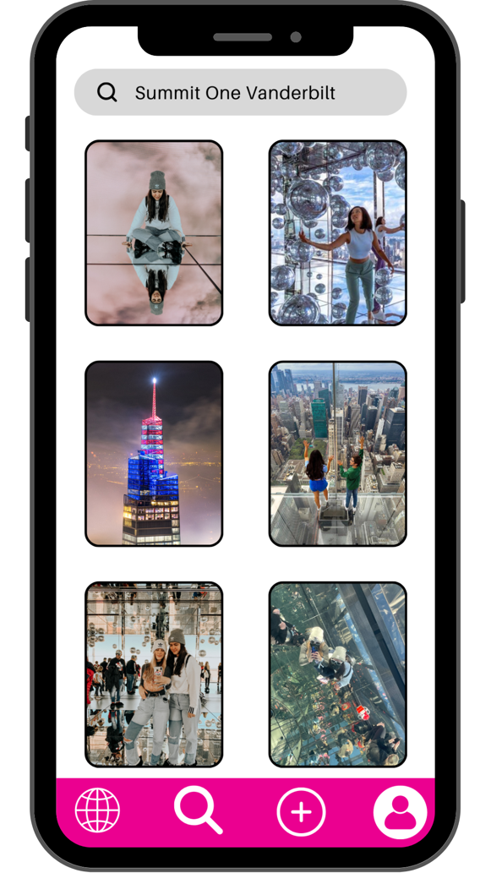

**Goal 9**

**Use Case: Add a post**

**Precondition:**

1. User is successfully logged in.

**Flow of Events:**

1. The use case begins when the user clicks on the “plus” icon in the bottom menu.
2. The user is displayed a view with fields to fill out.
3. The user is able to upload a photo from their gallery by clicking on the corresponding field.
4. The use is able to enter the location, hours of operation, tips, personal experience, and any other advice they want to share about their experience and why others should visit this place on their trip to such location.
5. The user is able to navigate to other views by clicking on the options from the menu if they do not want to publish a post.
6. The user is able to select a button to publish the post.
7. The post is now available for anyone logged in to see.
8. The use case ends.

**Business Rules:**

1. A publication will be successfully published once the required fields: photo, and location are completed.
2. The post will be saved to database once published.

**User Interaction:**

**Goal 10**

**Use Case: Log out**

**Precondition:**

1. User is successfully logged in.
2. User has navigated to the “My Account” View.

**Flow of Events:**

1. The use case begins when the user clicks on the compacted three dots at the top of the view.
2. The user will be shown a button “Logout”.
3. The user clicks on the button.
4. The “Login” or welcome view will be displayed.
5. The use case ends.

**User Interaction:**

